Final Report on the Investigation of a Centralized Database and Resource Repository for the Army National Guard

By

Maleiha Ali

Ian Driscoll

Anisha Aggarwal

Emaly Vatne

National Security Innovation Network

X-Force Fellowship

Army National Guard

Copyrighted by:

Maleiha Ali

Ian Driscoll

Anisha Aggarwal

Emaly Vatne

2023

# Executive Summary

The Holistic Health and Fitness system (H2F) encompasses all aspects of a Soldier’s overall health and works to better understand and improve their health via physical, mental, spiritual, sleep, and nutritional readiness. Members of the Ohio National Guard, Kentucky National Guard, and National Guard Bureau originally reached out to the National Security Innovation Network (NSIN) to help develop a central data repository for senior leaders and Soldiers within the H2F system. There are two suggested short-term solutions that can be implemented immediately: a resource website consolidating all resources pertaining to the H2F domains that is accessible for soldiers, and a designated team at the NGB that extracts data from the systems. The suggested long-term solution is a soldier management system that can use an analytics and business intelligence (A&BI) platform from three proposed vendors: Coach Me Plus, Smartabase, and Power BI on the Microsoft Enterprise; after analyzing the pros and cons our team recommends that the SMS use Power BI on the Microsoft Enterprise.

Table of Contents

Executive Summary ii

List of Tables iv

List of Figures v

Chapter 1. Background 6

Chapter 2. Methods 10

Chapter 3a. Results – Short-Term 13

Requirements 15

Chapter 3b. Results – Long-Term 21

Data Confidentiality, Integrity, and Privacy 23

Identified Needs and Return on Investment 26

Evaluation and Comparison Criteria 27

Alternate Proposal 1: Smartabase 30

Alternate Proposal 2: CoachMe+ 36

Primary Recommendation: Power BI + Microsoft Enterprise 40

Chapter 4. Discussion 52

Chapter 5. Conclusion and Future Directions 55

# List of Tables

Table 1. Smartabase Criteria Evaluation 36

Table 2. CoachMe+ Criteria Evaluation 40

Table 3. Microsoft Suite Criteria Evaluation 50

# List of Figures

Chapter 3a.

Figure 1. Figure 1. H2F Canva Webpage……………………………………………………… 21

Chapter 3b.

[Figure 1. ARNG H2F Data Architecture 22](https://eccalon.sharepoint.com/sites/Xforcensin-XFFTeam-X2FOhioANG/Shared%20Documents/XFF%20Team%20-%20X2F%20Ohio%20ANG/Final%20Report%20Working%20Files/Final%20Report%20Document%20DRAFT.docx#_Toc142037133)

Figure 2. ARNG H2F Data Architecture with the Microsoft Suite 50

# Chapter 1. Background

**What is H2F?**

The Holistic Health and Fitness system (H2F) is a Soldier readiness system designed by the United States Army. H2F is a system encompasses all aspects of a Soldier’s overall health and works to better understand and improve their health via the five domains:

1. Mental Readiness – Meet the mental demands of combat or duty position.
2. Sleep Readiness – Implement the requisite sleep principles and behaviors to support optimal brain function.
3. Nutritional Readiness – Recognize, select, and consume the requisite food and drink to meet the physical and non-physical demands of any duty or combat.
4. Spiritual Readiness – The development of personal qualities needed to sustain a person in times of stress, hardship, and tragedy.
5. Physical Readiness – Meet the physical demands of any duty or combat and accomplish the mission.

In the H2F Handbook, Major General John D. Kline described the H2F system as “*the Army’s primary investment in Soldier readiness and lethality, with the goals of optimal physical and non-physical performance, reducing injury rates, improving rehabilitation after injury, and increasing overall readiness of the total Army*.”[[1]](http://applewebdata://E63D6372-E7AC-4A56-94CD-849ECE7D7DD8#_ftn1) The H2F’s Army campaign objective is to measure Soldier readiness via Measure of Performance (MOPs) and Measure of Effectiveness (MOEs) metrics tables.

**Current State of H2F Data Collection and Analysis**

To evaluate the impact of H2F system and initiatives on the health and readiness of Soldiers, ARNG H2F leaders and performance teams (HPTs) at the national level need to access and analyze Soldier data regarding the MOPs and MOEs. In its current state, this data is stored in the following different DoD data sources:

* Digital Training Management System
* Medical Operational Data System
* EProfile
* Health System Data Repository
* DoD Suicide Event Report
* Army Training Requirements and Resources System
* Retain System
* Quality of Life Surveys
* Army Learning Management System
* Unit Risk Inventory Survey
* Command Climate Survey

Most ARNG H2F leaders cannot directly access these data sources and must identify points of contact from different Offices of Primary Responsibility (OPRs) to acquire the necessary data from each data source and create reports. ARNG H2F leaders report having to rely on self-reported data from the 54 states and territories or from the Headquarter Department of the Army (HDQA). The dependency on states, OPRs, and the HDQA is inconvenient and impedes the H2F’s ability to receive timely data. Furthermore, the OPRs are siloed and the lack of communication and collaboration between them make the data sources very different from each other in terms of structure, content, use cases, and organization. Once H2F leaders receive the data, there is no existing central repository to aggregate, clean, or prep the data. Without a central repository, ARNG H2F leaders cannot perform cross analysis between different data sources or capture historical data. Without a central repository, the ARNG cannot utilize the available data to properly evaluate the H2F system.

**Current State for Individual Soldiers**

An important part of improving Soldiers' readiness and well-being is making sure Soldiers can view and interpret their personal data. For instance, many ARNG Soldiers cannot see their ACFT scores. Access to resources might also help Soldiers' readiness outlined by the H2F domains.

Information on available resources for ARNG Soldiers is currently held on dozens of different websites, many of which have dead links, outdated user interfaces, and overlapping information that can sometimes be contradictory. The distribution of resources and information across different websites on the internet makes it difficult for Soldiers to find what they need in a timely and efficient manner.

**How NSIN Can Help ARNG**

Members of the Ohio National Guard, Kentucky National Guard, and National Guard Bureau originally reached out to the National Security Innovation Network (NSIN) to help develop a central data repository for senior leaders and Soldiers within the H2F system. The problem as stated by our sponsors was:

*“Currently, the ARNG has no central repository or enterprise level database of information for metrics, data collection, or resources related to H2F.”*

Our team first focused on evaluating the feasibility of a Soldier management system (SMS) that could aggregate data from different data sources and state levels for leaders at the national level. After confirming the feasibility and understanding the limitations of the current system as described above, our team broke our project into two different components: a short-term solution and a long-term solution.

1. Short term: We would allow national H2F leaders to access the different data sources without depending on OPRs, states, and the HDQA. Try to identify a temporary platform for managing and analyzing the collected data. Lastly, we would consolidate Soldier resources related to H2F’s five domains to increase accessibility.
2. Long term: We can map out the data architecture for a central repository that can pull data from the different data sources, aggregate it, and perform analysis. Work to identify the best vendor products for both the back end and front end of the repository; and outline how the central repository will allow Soldiers to view and input their own data and ARNG senior leaders to better evaluate the H2F system.

# Chapter 2. Methods

To work towards developing a clear recommendation for the Army National Guard H2F system, the methods deployed were mainly investigating open-access Soldier resources, meeting with various points of contact who had information that was relevant to the aims of the project.

In the first few weeks we researched the five domains of the H2F system and created a consolidated resource list of all resources pertaining to the domains that are accessible to Soldiers. During our research we discovered the challenges Soldiers face when attempting to access resources: The lack of centrality and Soldier-friendly interface that restricts the awareness and the accessibility of such resources. Thus birthed our first component of our deliverable:

1. **Create a friendly Soldier-facing website to consolidate all resources related to H2F Soldier readiness in one place.**

Next our sponsors provided a list of primary points of contact (POCs) of systems and data platforms that are currently used by ARNG members for collecting information including but not limited to physical aptitude tests, training, certifications, and medical and health related information on all Soldiers. With each interview we learned how these systems tracked metrics, who has access to the information, how often is it collected and by whom, what data platforms are used to store the metrics, and how that data is analyzed on both quantified and qualified levels. The systems we interviewed POCs seen in Table (?).

Currently there is no NGB member that has access to information from all these systems. While the central repository is being developed, there could be a designated individual or staff that has access to all metrics from these various systems to feed information back to the NGB. The second component of our deliverable:

1. **Identify an individual or group of individuals within the National Guard Bureau to gain direct access to the data systems and limit the dependency on external POCs from OPRs and states.**

After establishing the collection and flow of Soldier’s metrics, we met with numerous human performance software companies and data visualization software companies to analyze their capabilities. The interviews consisted of testing whether these analytics platforms possessed the capabilities which best fit our needs of creating a centralized ecosystem that funnels information from various system into one location, as well as simultaneously providing cross-sectional analysis. In our interviews we looked for software that would allow us to create our Soldier management system (SMS) - the third component of our deliverable. that includes the back-end data architecture that ingests/extracts, loads, and transforms/processes data, and includes the front-end, user-facing interface that effectively communicates the appropriate, prepared data.

1. **Recommend the most suitable vendors and software for creating a SMS that includes the back-end data architecture that extracts and processes data, and the front-end, user-facing interface that effectively communicates the prepared data.**

# Chapter 3a. Results – Short-Term

Our team originally explored how the ARNG H2F could create an SMS that could integrate with and automatically pull from different data systems, but SMS funding and implementation will take time. Our paper will explore short-term strategies the National Guard Bureau can adopt concerning the Holistic Health and Fitness (H2F) system to increase effectiveness. These short-term strategies focus primarily on two areas: access and Soldier education. Access and education represent two main issues in the current H2F system as well as possible solutions for the future success of the H2F system. As our problem was to explore how the Army National Guard could centralize H2F metrics on a data platform, the first major challenge was how the Army National Guard could access the data at the national level. A short-term solution would be establishing a point of contact at the national level that could access data through all existing platforms and systems at the state level, aggregate the data for future analysis, and visualize the analysis through a A&BI platform such as Microsoft’s Power BI. A second challenge we discovered was the varying quality of resources for the Army National Guard at the state level. The second short-term strategy relates to providing greater access to quality resources for ARNG Soldiers. Providing better quality resources can improve the overall success of the H2F system, especially if the Army National Guard is pushing to centralize H2F metrics in the long term.

**Access: Solution One**

As noted in our Background section, the H2F system was established several years ago but is restricted due to the decentralized process that the Army National Guard collects data. Each of the 54 states and territories collects this data differently. Currently, the Army National Guard cannot easily access or extract this data nor measure its progress across the 54 states and territories with Army National Guard units. Each of the 54 states and territories collects and manages their data differently so the amount of POCs at the state level needed for the National Guard Bureau (NGB) to obtain all the necessary data can be exponential. Our interviews with H2F regional coordinators and experts in the NGB informed us that all the data related to the H2F’s MOPs and MOEs are stored in the identified data systems listed earlier, making them essential to data collection.

The functions of these existing systems make it clear that the necessary data is available and vast but for the H2F to properly utilize it, it needs to be acquired in an efficient and timely manner. However, currently, these metrics are self-reported to the commanders at the national level from all 54 states and territories Army National Guard units. Since metrics come from various systems and platforms, multiple members at the state level are needed to pull the data. Herein lies the problem that a vital task pulling data to measure the success of the H2F system relies on too many POCs, and it is untimely because POCs have responsibilities aside from self-reporting the data.

Therefore, if the ARNG identified an individual or group at the national level whose primary responsibility would be to pull data from each system in each state and territory to analyze H2F metrics, the ARNG would no longer rely on several external POCs and could control the frequency, quality, and timeliness of the data collection. The ARNG could create a new position for this task or could assign the work for existing employees to add to their normal workloads. It is recommended that this identified individual, or group (II/IG) have security clearances, training, and knowledge of the H2F system from a national perspective.

## Requirements

The systems the II/IG would need access to would require security clearances that must be approved at the National Level. Our research indicates that it would not require a considerable amount of time to gain clearance for each system in every state. However, since the data being pulled relates to Soldiers’ health, we recommend that there be adequate security training given to the Point of Contact to ensure that the metrics are handled safely.

The II/IG needs to have experience and knowledge of data management and analytics. Their responsibilities will require pulling and transferring data into a management system and performing analysis. Our team recommends that the II/IG store the collected data on multiple spreadsheets (Ex. Excel, Google Sheets) within a file sharing system (Ex. Google Drive, One Drive) and use Power BI for the analysis of the collected data. The ARNG already licenses Power BI so this approach takes advantage of existing tools and does not require funding. Power BI also integrates very well with Excel, offering capabilities like “Analyze in Excel”, and the NGB currently uses Excel to view and manage H2F data. If the II/IG does not have the necessary general knowledge or experience using Power BI, the NGB will need to dedicate resources and time to train and educate them.

Finally, the II/IG must be familiar with the H2F system. This means that the II/IG has been involved with the implementation of the H2F system in the Army National Guard. It would be advantageous if the II/IG were already familiar with the H2F system because that would mean fewer resources and time needed to train them in the metrics they would need to collect, and it would mean the ARNG could analyze the state metrics in a faster amount of time.

While this is not the ideal recommendation our team makes in the paper, it is a short-term fix to the problem we were tasked with. This short-term solution would require few resources and could be implemented quickly, meaning metrics could be quickly analyzed without an additional investment in a data platform. However, the drawback is that this is still a manual process and cannot automate pulling data to the national level and preparing it. Therefore, this short-term fix is envisioned as a temporary solution.

**H2F Resource Website: Solution 2**

Before our paper lays out our long-term solution, we recommend that the Army National Guard allocate some energy to creating a central resource page for the H2F system to better inform Army National Guard Soldiers about the five domains and how they can improve their health.

The US Army Holistic Health and Fitness Concept Document forward section one passage reads:

*“Highly trained, disciplined, and fit Soldiers build cohesive teams. Our teams are strongest when we ensure each individual Soldier’s performance is optimized. To accomplish this, we are bringing a cultural change to Soldiers’ perceptions of training for the demands of close combat. All Soldiers must view their health and fitness as a critical requirement for membership in the Profession of Arms.”[1]*

If one fundamental goal is to bring “a cultural change to Soldier’s perceptions of training” and if “All Soldiers must view their health fitness as a critical requirement for membership in the Profession of Arms,” then more resources should be used to educate Army National Guard Soldiers on the resources offered in their state or territory. Providing a modern resource website dedicated to Soldier’s health through the H2F system would naturally create a more efficient and centralized H2F system.

Our research has demonstrated that resources available to ARNG Soldiers, especially online resources, vary from state to state and territory to territory. Since most Americans access information online, we decided only to examine the state of online resources. It could be beneficial for future research to explore other resources offered in person or via telephone. The key takeaways from our research are that each state and territory’s ARNG website’s homepage varies in quality, information available, and focus (e.g., what content they prioritize on their homepage). If the ARNG adopted a more uniform approach to organizing and centralizing H2F resources online for Soldiers, there would most likely be a positive shift in terms of bringing about a ‘cultural change to Soldiers’ perceptions of training’ and the H2F system.

Research concerning web design illustrates that a website must do well in specific categories to convey information to the user effectively. In this case, the user is the ARNG Soldier. A literature review done in 2014 explores these categories. The researchers listed six categories that can qualify a website. The six categories are effective navigation, engaging graphical presentation details, optimal organization, content utility, the purpose of the website, and readability.[2] If a website does well in these six categories, then the user will likely have ap positive experience accessing the information they were searching for and, in our case, be better informed about the ARNG’s H2F system.

However, when examining all 54 ARNG websites at the state or territory level, only some perform well in the six categories. For example, many ARNG state or territory level websites lack engaging graphics and presentation details to retain the user’s interest in staying on the website. Currently, most ARNG homepages at state or territory levels focus on recruitment, including listing benefits but do not offer easy access to resources for current ARNG Soldiers. If there are more links to resources on personal health and wellness, this could help make ARNG homepages sources for both future and current Soldiers. Having more resources for current ARNG Soldiers ties into the 5th category of an effective website: having a clear purpose, including the audience and the content offered.

Here, there needs to be more research done to quantify ARNG websites’ effectiveness at conveying information and resources to ARNG Soldiers. Still, it is noticeable that for most ARNG websites’ homepages, there is a greater focus on recruiting than providing current ARNG soldiers the resources they need to understand the H2F system. A recommendation would be displaying more H2F resources on state and territory homepages to help Soldiers find the answers they need to improve their health and well-being. Arguably, displaying more resources relating to H2F for current Soldiers on both the homepage and the resource page could serve as an effective recruiting tool because prospective Soldiers will see how the H2F system improves Soldiers’ health and well-being.

Finally, our group designed an H2F website on Canva, where we visualized what Soldiers could access interactive H2F resources specific to their state or territory and those offered in all 54 states and territories. If every ARNG homepage had a link under the resource tab for this central H2F homepage, we would most likely see a positive shift in Soldier’s perceptions of the H2F system. On the homepage, several tabs would leave a Soldier with information and resources related to each of the five domains. On the left side of the homepage would be a link to view information (metrics) related to the specific Soldier, including weight, height, and perhaps personal goals the Soldier hopes to achieve in each of the 5 domains. Below that, we envision links that would lead the Soldier to their personal H2F account. What information this account would display for the Soldier is still being determined, and more research would have to be done on this topic.

Figure 1. H2F Canva Webpage

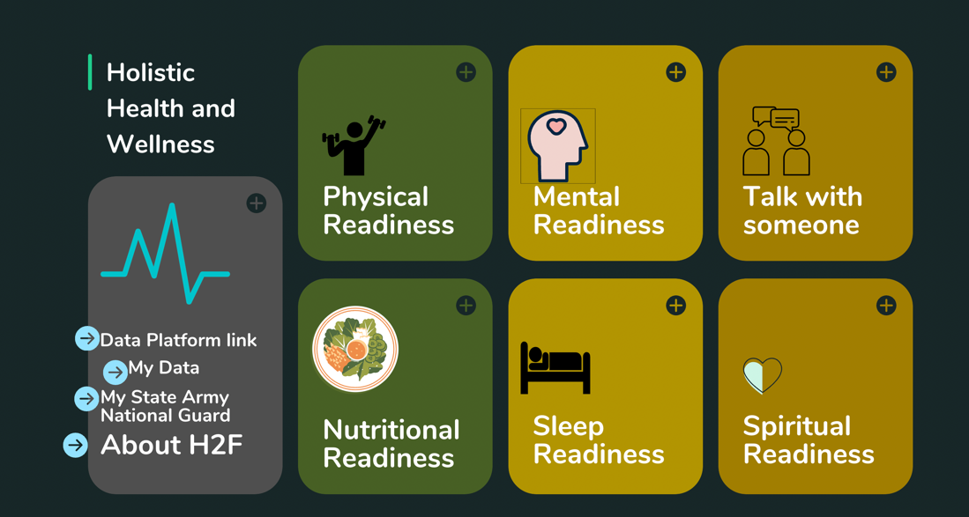

Both these recommendations are short-term, and while they do not directly answer our problem statement, they create results that can help strengthen the long-term recommendation’s feasibility. For example, the first short-term recommendation, establishing several points of contact at the national level to access state-level systems and extract metrics relating to the H2F system which would be put on a shared spreadsheet, would be a step in the right direction of centralizing ARNG H2F data. Furthermore, centralizing and updating ARNG homepage websites to have more uniformity and better information relating to the H2F system would help Soldiers better understand the rationale for the H2F system being centralized. However, our long-term recommendation will help solve our problem statement more effectively.

# Chapter 3b. Results – Long-Term

The ARNG currently collects data via self-reporting from the states and other offices; building a central repository, also known as a Soldier management system (SMS), could be a potential solution.

Even with the short-term solution implemented, the necessary data is stored in many different systems until it is time to create reports and data must be manually pulled and prepared. In addition, H2F stakeholders still do not have a standardized platform to work with data. Some H2F regional coordinators use Excel for analysis and visualization but this does not allow for capabilities such as cross analysis between data sets and historical analysis. To establish valid baselines at different levels (i.e., state- or national-level) of data reflecting the different H2F domains and to evaluate H2F as it progresses, an efficient, timely streamline of data and “so what” contextualized analysis is needed. A SMS reflects a data ecosystem that has two components– a back-end and front-end. The back-end data architecture ingests/extracts, loads, and transforms/processes the data for analysis and reporting. The front-end includes user-facing interfaces that communicate the prepared data and allow for analysis, visualization, and reporting. In addition to sensitive presentation data, a complete SMS also offers a mode to disseminate H2F content to Soldiers and improve communications between leadership and Soldiers.

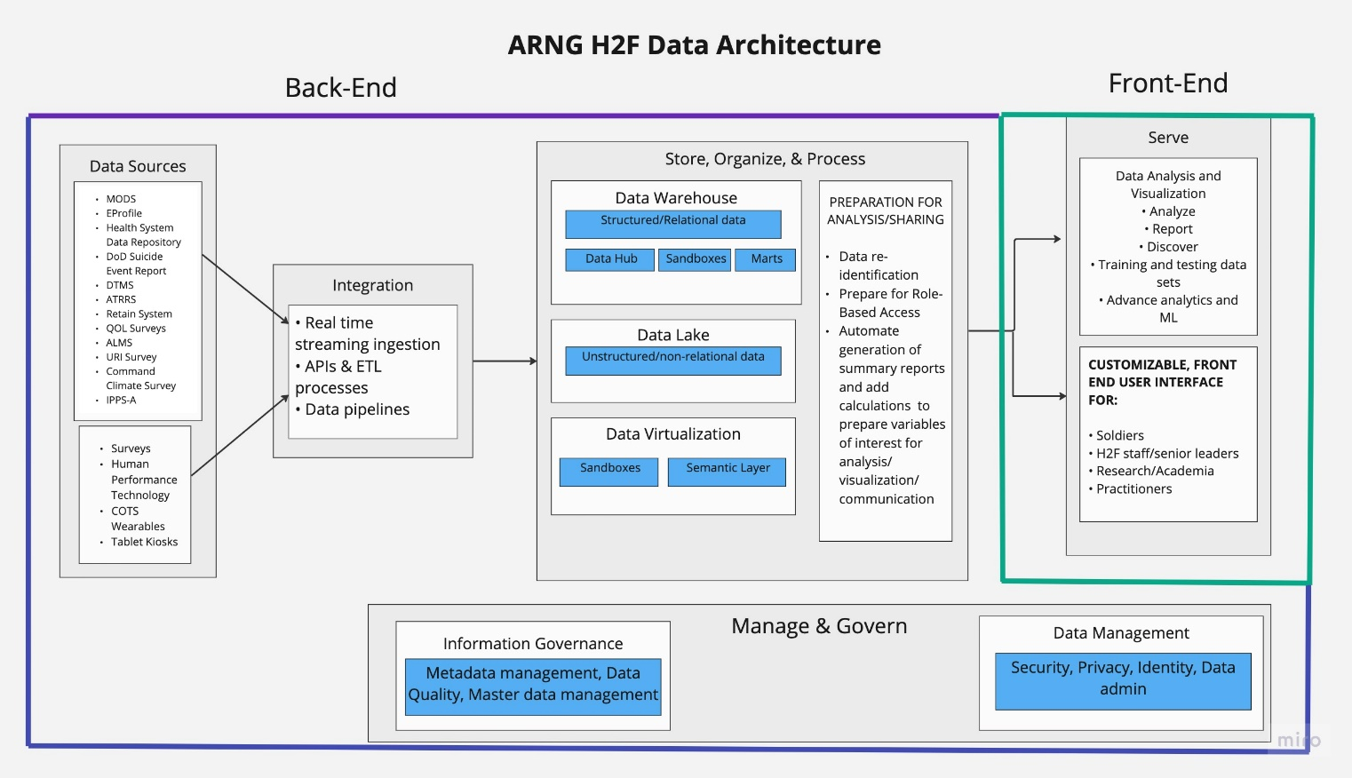

Figure 1. ARNG H2F Data Architecture

The above figure shows the entire data architecture of the H2F SMS including the different pieces that make up the back and front end. After the data is ingested from the different data systems, it needs to be kept somewhere. The data lake and data warehouse will be where all the necessary data is aggregated. Many cloud providers offer data warehouses and data lakes as products for customers to buy. The A&BI platform sits on top of the data warehouse and data lake and makes up the front-end of the SMS. Many providers offer A&BI platforms as products for customers to buy. Some of these A&BI platform providers operate using their own personal data warehouse built on Azure, AWS, or GCP storage. Other providers only have the A&BI platform and require customers to purchase their own data warehouse along with infrastructure from cloud providers such as Azure, AWS, or GCP. To build the SMS, providers need to be chosen for the infrastructure, data warehouse, and A&BI platform. Our team’s main objective was to recommend the best A&BI platform for the H2F SMS so we will not be comparing infrastructures and data warehouse products on the market. But as an important note, when creating the SMS, the provider for the infrastructure and data warehouse should be chosen based on your team’s experience and preference when it comes to cloud providers. Additionally, it is important to note that some A&BI platforms that do not come with their own data warehouses operate better on certain cloud providers. Generally, infrastructure and data warehouses from different providers are not very different, especially since the DoD already has licenses with many of them.

Our team’s research included assessing the market for A&BI platform products, evaluating the application of existing ARNG tools to a modern data architecture to create a SMS, and comparing options using a defined set of criteria. The following sections include an overview of data security and return on investment regarding the SMS along with an explanation of the criteria used to compare A&BI platforms. After, we evaluate three platforms based on the criteria to offer two alternate options and a final recommendation, where we give an in-depth review and deployment plan.

## Data Confidentiality, Integrity, and Privacy

The data that will be held and managed by the SMS is sensitive and valuable, so data confidentiality, integrity, and privacy are important factors to consider when designing and building the SMS. Data confidentiality or security reflects limited access to the data or information and ensuring that the data are deidentified at appropriate steps to minimize consequences of a system being compromised. Data integrity was operationally defined as processes that provide data or information that is trustworthy, reliable, and accurate. Finally, data privacy means delivering the right data to the right person or group. The process for individuals or specific groups to access information should be reliable and require appropriate authorization to prevent inadvertent sharing of sensitive information or data.

The Federal Information Security Modernization Act requires federal agencies to have systems and procedures in place to assess, monitor, and intervene on security and privacy risks (REF). Inter-agency bodies like the Federal Risk and Authorization Management Platform (FedRAMP) can implement and evaluate these systems and procedures. According to the Office of Management and Budget’s (OMB) 2011 FedRAMP memorandum, FedRAMP is a program that aims to provide a cost-effective, risk-based approach to the use and adoption of cloud services for agents and departments (REF). FedRAMP serves as a pathway for private sector cloud service providers (CSP) to obtain a seal of approval for their cloud service offerings (CSO) to be operated on government networks for government users. This seal of approval is known as a FedRAMP Authority to Operate (ATO) (REF) also known as the “official management decision issued by a senior organizational official (e.g., Information System Security Officer (ISS)) that authorizes the operation of an information system (e.g., cloud infrastructure) and explicitly accepts security risks based on the implementation of an agreed-upon set of security controls” (REF). Given the sensitive nature of the data and use of cloud services, FedRAMP authorization is one route to reflect a validated security framework. When creating an SMS, the data warehouse provider, A&BI platform provider, and every data source that the SMS integrates with all must be FedRAMP certified. Acquiring FedRAMP certification is timely and expensive for providers and companies who do not already have it which may serve as an obstacle for what providers and data sources are used in the H2F SMS. Other security framework accreditations include ISO/IEC 27701:2019: Privacy Information Management, ISO/IEC 27001:2013 Information Security Management Standards, and independent, third-party auditing of the System and Organization Controls for Service Organizations by the Certified Public Accountants.

Department of Defense (DoD) Impact Levels (IL) are based on the federal government’s requirements for the Confidentiality, Integrity, and Availability of the information/data or information systems accessed or processed by a cloud product and is used to categorize information systems and the data they process and store to understand the potential impact or consequences of compromises to the system (REF). Different ILs also require different security controls/labels, approved locations, off-premises connectivity permissions, and personnel approvals for access. DoD IL 2 represents public or non-critical mission information, IL 4 means Controlled, Unclassified Information (CUI) or non-CUI, non-critical mission information, or non-national security systems. DoD IL 5 reflects higher-sensitivity CUI, mission-critical information, or national security systems and DoD IL 6, the highest DoD IL, is classified SECRET and national security systems information or data. (REF) Provider products used to create the H2F SMS must have certifications to handle data from different IL levels. The higher the IL level is for the data within the H2F SMS, the more restrictions there are and the higher the cost is.

The second part of the security criteria includes delivering the right data to the right person. This includes a robust framework of group- and role-based access control. Further, appropriate authentication steps must be in place to also ensure that a user has access to only the data they need and are permitted to view.

## Identified Needs and Return on Investment

When researching A&BI providers, an important component our team looked for in products was their ability to solve the current identified needs of H2F within the ARNG. As previously stated, the needs/gaps that a robust SMS could solve include:

1. Streamlining information collection, resource sharing, and data analysis/reporting
2. Providing end-users with the right data and actionable, understandable “so what” information based on H2F’s MOPs and MOEs
3. Allow for real-time generation of validated baselines for the H2F-related data for Service Members across different levels.

Considering the time, money, resources, and effort needed from all H2F stakeholders to design and build this SMS, it is important to understand the return on investment. The H2F’s goal is to increase Soldier wellness and readiness by focusing on the five domains but H2F leaders cannot properly identify if and what H2F interventions are working. If the SMS is built, H2F leaders will be able to utilize data efficiently to see this information and then, they will be able to improve weaknesses and duplicate successful interventions in other units and states. The result will be an increase in Soldier readiness and wellness and when Soldiers work better, recover quicker, and stay in good condition for longer, the ARNG saves money. Currently, the inconvenience and manual effort required to operate the H2F data system is high for leaders. With an SMS, H2F leaders can acquire necessary data quicker and automatically which will allow them to dedicate working hours to other tasks. Time is money. Lastly, allowing Soldiers to access existing data and resources gives them the opportunity to improve their own readiness and health. If more Soldiers can pro-actively prevent injuries and times of absence, less resources need to be dedicated in the future to reactive actions.

## Evaluation and Comparison Criteria

The options available that could serve as the H2F SMS A&BI platform for the ARNG were evaluated on consistent criteria. The criteria were based on input from points of contact, ARNG needs, secondary research, and overlapping capabilities.

#### Analysis and Visualization.

#### The main goal of the SMS is to allow users to use data from different states and systems to compare and evaluate the impact of the H2F. By looking at the H2F’s MOPs and MOEs, our team was able to assume some of the visualizations and analysis H2F stakeholders could possibly want to build and perform. We used this assumption to compare the varying analytical tools different A&BI platforms offer users.

#### User Interface

This criterion encompasses how the final, cleaned, and prepared data or resources can be presented for users in the A&BI platform. The end-users our team identified include, but are not limited to: NGB senior leaders, H2F system evaluators, National Guard Bureau regional directors, state-level leadership, company leaders, Soldiers, and H2F researchers (i.e., academia partners). These users potentially need unique data access, analysis, visualizations, and exploration abilities. The recommended SMS will be able to serve these unique end-users and their needs. For example, senior leaders of the Army National Guard and other stakeholders may need state- and national-level reports and dashboards that allow for the timely calculation of validated baselines for data related to H2F and for measuring impact and effectiveness of the H2F system. On the other hand, leaders at a company level may want to track effects of a physical training (PT) program over time and subsequent effects on their Soldiers’ ACFT pass rates and individual event scores. Another potential end-user of this data ecosystem may be an academia partner who is deploying an H2F intervention and requires clean, reliable data for the scientific evaluation of the intervention. Finally, another end-user could be the Soldiers who deserve easy access to contacts for H2F-related support and may benefit from being able to see their own data and trends over time. Overall, the user-interface for various users reflects the final, serve step in a data ecosystem/architecture or SMS. Although the integrity of the steps leading up to this are critical, this is often the only part of a data ecosystem that stakeholders will see and interact with.

Vendor Support

Different vendors offer varying levels of support and involvement with the deployment of the A&BI platform and the overall SMS development. In meetings between vendors and our team, some vendors offered to not only create the front end of the SMS with different pre-built interfaces and capabilities but also offered to help with the data ingestion and management in the back end. Vendors that offered to help with the SMS’s back end would personally set up APIs and perform ETL processes without the need for internal personnel and expertise from the ARNG. They would also maintain the back end of the SMS so that their A&BI platform can properly operate after its deployment. These vendors offer the best quality support. A&BI platform vendors who do not offer support with the back end of the SMS require the ARNG to dedicate a high amount internal personnel to build and maintain it. These vendors tend to be bigger companies and offer less quality support. But this allows the ARNG the most flexibility because it allows internal personnel to build their own capabilities with the platform software and it makes customizations easier. Low support vendors are close to a “build-your-own" approach.

#### Integration

This is an important criterion because it determines what data sources the H2F SMS can integrate with and how vendors help with the process. As mentioned earlier, some vendors will integrate with data systems in the back end for you and other vendors will not. Vendors who would do the integration were evaluated based on what existing integrations they already had and if one wasn’t set up, how fast they would be able to build it. Vendors who would not do the integration were evaluated based on the different tools and products they had available for users to make the process of creating integration themselves easier. We considered integration tools for data sources like DoD systems but also COTS, wearables, and Soldier surveys.

Scalability

There is a clear need for the establishment of a platform that serves senior leaders of H2F at the National Guard Bureau level all the way down to the company level at all 54 states and territories. Therefore, being able to scale a solution to all these users, their different roles, and the different data that are available requires the ultimate solution to be scalable without undue burden and further requirements. When the SMS experiences changes in application and system demands from an increase in users, the A&BI platform needs to be able to manage performance and cost to continue functioning well. During pivotal times, it needs to be able to scale back as well.

Cost

The second criterion that the possible SMS were evaluated on was cost. This criterion is related because the cost of a platform goes beyond the cost of licensing and software/hardware procurement. The SMS requires a range of trained individuals to build and maintain it and supporting these individuals’ time and effort will, therefore, increase cost. The building of the SMS may also require purchasing additional tools outside of the main platform and software. Lastly, any additional external support services or consultancy sessions requires purchasing.

## Alternate Proposal 1: Smartabase

Teamworks is an operating system that encompasses multiple different digital software to serve athletic populations and organizations. One of these platforms includes Smartabase, which is a human performance data management system and is a viable option to serve as an SMS. Currently, Smartabase is commonly used in collegiate and professional sports organizations to handle data ingestion, storage, and visualizations and analysis. It also is used within some sectors of the DoD.

Data Confidentiality, Integrity, and Privacy.

To serve data architecture needs, Smartabase handles data ingestion using APIs and what Smartabase refers to as, “Event Forms.” An Event Form is where data from an ingestion source, whether it be a wearable device company API or user-facing survey, is defined for future use. There are over 70 different types of questions and calculations for an Event Form that use Smartabase’s proprietary syntax (i.e., not a common programming language like R or Python). Smartabase’s workflows allow for data aggregation and cleaning from a very wide range of sources. Since Smartabase has been deployed within different sectors of the DoD, it already has different accreditations for data confidentiality. The security framework of Smartabase is reflected in their certifications which include ISO/IEC 27001:2013 Certified, ISO/IEC 27701:2019 Certified, AICPA SOC 2 Type 2 Compliant, NIST 800-53 and FedRAMP, Trust Services Criteria, GDPR, HIPAA, and PIPEDA, OWASP Top Ten, System and Organization Control (SOC) 2 Report, and Health Data Host (HDH) Certified. Furthermore, Smartabase has a proprietary process called *Clearinghouse* that securely moves data from Impact Level 2 to Impact Level 5 using industry standard OAuth2 REST APIs. This is critical for any cloud data service provider and a major advantage of Smartabase. Clearinghouse is developed and has already been used by different groups within the DoD.

Analysis & Visualization

Smartabase allows for a wide range of data integrations which allows users to combine data from any data source to perform analysis and create visualizations. This will allow ARNG to do cross analysis across different states and units. Smartabase allows members of the platform who have access to the ‘builder’ side of the Smartabase domain to create no-code calculations that generate desired analyses. From the data collected and calculated, Smartabase also allows for creating dashboards that update automatically when new data becomes available. However, for whatever data is desired to be posted in the dashboard, the calculations or integrations must be created and solidified before any dashboards in the event form.

A major limitation identified with Smartabase is the potential need for analysis to be conducted outside of the Smartabase platform depending on the calculations or analysis that is needed. For sophisticated visuals, analysis, and modeling, Smartabase recommends customers to connect to other A&BI platforms such as Tableau and Power BI. This introduces the opportunity for compromises to data security and could require personnel to have data analysis expertise in other platforms. Smartabase also might be able to serve the need for generating real-time, validated, and accurate baselines for data related to H2F. There are gaps in Smartabase as an analysis tool that may limit its ability to generate these calculations for different groups. The solution for this problem would be generating a CSV report for the data of interest and conducting the analysis with a different tool. Again, this introduces inherent risk since the data, which could be of different Impact Levels, would be leaving the system as a raw CSV file.

User Interface

Another major advantage of Smartabase is their robust role- and group-based access structure. The nearly limitless ability to assign users to appropriate data permissions and groups is a major advantage of Smartabase given the many layers of users of ARNG for H2F. Because of Smartabase’s group- and role-based access, Smartabase can serve all the different end-users of ARNG H2F to some degree of success that depends on what the end-user desires. Dashboards and reports are built in Smartabase’s entirely no-code platform (“Builder” site). For data to be visualized in a dashboard or report, the calculations or analysis must all be completed and prepared in the Event Form – there is no or very limited ability to add calculations in a report or dashboard building process.

For Soldiers, Smartabase’s user-interface is housed within the Smartabase “Athlete App.” Within this application, a user logs in to their server and can view the data, dashboards, or reports they have access to and can also input data through surveys or manual entry. As described in the Data Confidentiality, Integrity, and Privacy section for Smartabase, data entered through a survey or manually in the app by the user are cleaned using Event Forms and then housed within Smartabase’s server. Smartabase does allow for data collection and user-facing interfaces for all the domains related to H2F. Once these interfaces are developed, it would be an asset to the ARNG Soldiers who would be viewing these dashboards or reports. Further, Smartabase would also provide a platform for consolidating H2F-related resources and content for Soldiers.

For senior leaders and stakeholders of ARNG related to H2F, Smartabase would need to provide real-time updates to dashboards that allow for evaluation of the effectiveness of H2F at different levels and provide validated baselines of data related to H2F at different levels. A major limitation of the calculation and analysis ability of Smartabase in the Event Form data analysis approach is the lack of an ability to group by common features of a data set. For example, if a senior leader wanted a visualization or report on average mental wellness scores from a survey for each state and nationally, this may not be buildable with a Smartabase Event Form because there is not a way to group by the state that Soldiers are in. To provide this analysis, a POC would have to generate a CSV report and conduct this calculation in an external platform of their choice (i.e., R, Python, JMP, SPSS, etc.). Given that this was a major point of the summer fellowship initial problem statement, it is important to recognize this potential limitation of the platform.

Vendor Support

Smartabase is a no-code platform to handle the data lifecycle (or ETL process) from integration through serving the end-user. Smartabase personnel create integrations with all data sources in the back end through pre-built and customized connectors. Smartabase also provides pre-built capabilities and interfaces for the front-end interfaces. In theory, Smartabase replaces a data engineer and offers a data architecture without the need for extensive coding experience. However, this does not completely replace the need for competent internal personnel. Supporting an internal personnel’s (IP’s) time and effort to develop/prepare Event Forms to handle data ingestion is needed for Smartabase to be used to its potential. Event Forms are built using a set list of calculations and question types, but customization of these calculations/questions requires being able to write in Smartabase’s proprietary syntax. Furthermore, there needs to be a POC to develop dashboards or reports to serve end users. These efforts can be supported by Smartabase representatives, but IPs may still need training for Event Form or Dashboard building.

The limitation of this high vendor support is a lack of flexibility and internal control. Smartabase personnel will make any customizations or changes needed by ARNG but there are limitations to how much can be changed within Smartabase’s pre-built capabilities. There is also a reliance on Smartabase for technical support and problem shooting in both the back end and front end.

Integration

As mentioned before, Smartabase handles data integration using APIs and Event Forms. Smartabase has pre-built integrations set up with popular apps and platforms such as Excel, YouTube, Tableau, Microsoft SQL Server, and Fitbit. From our conversation with a representative of Smartabase, there are no current pre-built connectors with DoD systems such as DTMS (though these can be customized), but the company plans to develop them because of the demand from customers within the DoD.

Scalability

Smartabase’s major advantages include its customizability that is accompanied by scalability. The robust grouping and permissions structure of Smartabase allows for exceptional ability to be deployed at many different levels.

Cost

For ARNG internal personnel, trainings for Event Form or Dashboard building come at an additional cost called “Builder Hours.” Through our summer research, it was not determined what the exact cost of deploying Smartabase across the ARNG to support N2F initiatives would be, but it would be very costly due to the pre-built capabilities and support provided by the vendor.

Table 1. Smartabase Criteria Evaluation

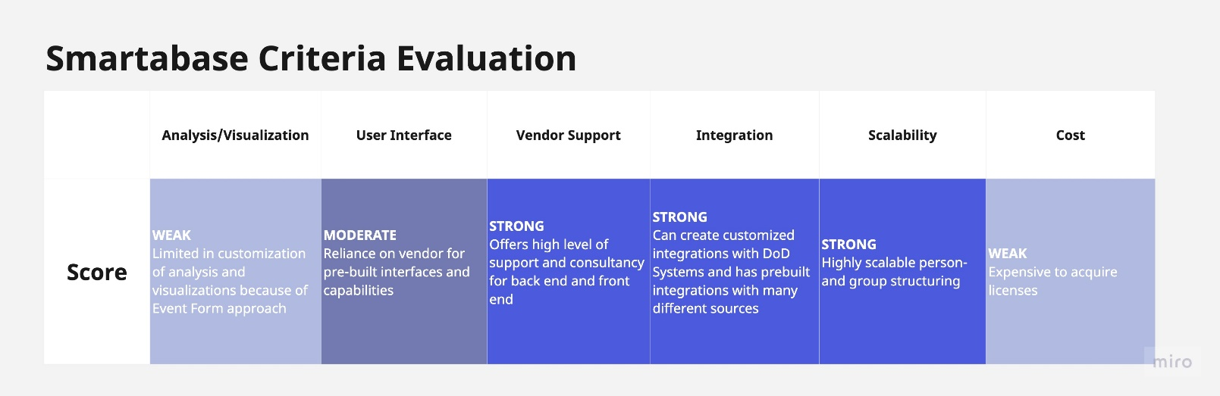

## Alternate Proposal 2: CoachMe+

CoachMe+ and their Warrior Performance Platform is a performance system that encompasses a user-facing application and backend database to serve athletic populations and organizations. CoachMe+ can serve as a data ecosystem for H2F-related data and serve end-users, especially Soldiers. Currently, CoachMe+ is commonly used in various levels of sports organizations and within different sectors of the DoD to handle data ingestion, storage, and visualizations and analysis.

Data Confidentiality, Integrity, and Privacy

Resources that describe accreditation reflecting data security of CoachMe+ are limited. However, its data confidentiality, integrity, and privacy standards are reflected by its use in various sectors within the DoD. According to the company, the data security framework includes specific levels of permission-based access, data encryption and proper identification/de-identification, and messaging encryption. Data integrity, specifically, is established in the back end of the platform in the processes that clean and organize data. Data privacy by ensuring that the right data permissions are set to the right person, is established through roles within the CoachMe+ installation. However, depending on the pricing tier, there are limits to how many roles can be established. For example, in the basic tier, there are only 3 tiers of roles that can be established, but with the *“Elite”* tier, there is configurability to the roles that are created. This contingency of data privacy on the cost tier that is selected is important to recognize.

Analysis & Visualization

CoachMe+ allows for data ingestion from common human performance technologies, the CoachMe+ proprietary application, and other vendor APIs. The data analysis of CoachMe+ is done in their assessment and dashboard builder, or, when the analysis is more in-depth, CoachMe+ *AlgoEngine*, which is their proprietary no-code approach to data analysis. In assessment builder, there are pre-defined calculations that can be applied to the different data that are available in the CoachMe+ system. Then, in the dashboard builder, the assessments are assigned to layout to generate the dashboard. Ultimately, the end-user dashboards are limited to the calculations that can be generated in the assessment builder and the *AlgoEngine*. However, access to the *AlgoEngine* is generally restricted to Site Admin roles or to the vendor and requires additional training to navigate this part of the site and maximize its use.

User Interface

A major goal identified related to the H2F system is the ability to serve the different users in the landscape of ARNG. For example, what senior leaders would like to see is going to be significantly different from what Soldiers would like to and need to see. The CoachMe+ is an exceptional platform for disseminating resources and educating and for communicating with Soldiers. Accessing resources and educational content is very straightforward for Soldiers once the content is posted in the appropriate spot. For example, in the program builder of CoachMe+ where physical training programs can be created and assigned to Soldiers, it is not difficult to embed example videos of how to correctly do a certain exercise. This is especially relevant to the National Guard since members are not always trained under the direct supervision of their physical training coach. Also, for Soldiers, the CoachMe+ application can present back the user’s own data related to physical nutrition, any surveys, and nutritional information. However, one aspect that might be valuable to ARNG Soldiers is comparing that Soldier’s data to averages, for example, of his or her peers. To the best of our knowledge, this would not be possible in CoachMe+ but very well could be configured with the support of the vendor. The user interface for other layers of the ARNG would be very similar to that of the Soldiers, except the main difference is the amount of data that is presented on the home page. While a Soldier only has access to his or her own data, the senior leader, coach, or administrator will see data from all members of that install of CoachMe+.

Vendor Support

To maximize the potential of CoachMe+, there is strong support from the vendor for support configuring, scaling, and building within the platform. CoachMe+ also helps with developing the back end of the SMS and spearheads the integration with data sources. Despite this strong vendor reliance, it is important to recognize that the support documentation for CoachMe+ is very in-depth and helpful. Although it would be more efficient to lean on the vendor for support, the CoachMe+ documentation might be able to lead a ARNG POC through steps to make the most of the CoachMe+ install.

Integration

CoachMe+ is built to handle data from a list of different sources so the data are aggregated in one place. Common consumer wearable devices that are deployed for human performance that CoachMe+ ingests includes Apple HealthKit, Fitbit, Garmin, Polar Flow, and Whoop. There are other commercial technologies in the domain of velocity-based training, fatigue monitoring, timing gates, scales, movement screening, heart rate, global positioning systems, and force plates. Notably, some of these data ingestions are through APIs and others are done using a CSV manual upload. Furthermore, the price tier that CoachMe+ is deployed with will also affect the amount of device integrations that are possible.

A major limitation of the research presented herein is that a centralized data ecosystem, no matter the platform, is contingent on the currently used systems having proficient APIs that can allow for data transfer from that system to another. The present research outlines platforms, like CoachMe+, that could serve the central repository role, but does not confirm if the currently used systems would allow the critical data export step.

Scalability

A major point of consideration for the ARNG related to the H2F system is the current landscape and the numerous potential roles that would need unique permissions. The rights, roles, and permissions of a CoachMe+ depends on the pricing tier that is selected ([CoachMe+ Tier Explanation](https://try.coachmeplus.com/plans#Rights,-Roles,%20and%20Permissions)). The basic options/tiers only allow for a maximum of 3 fixed roles, while the “*Elite”* tier allows for configurable roles. The number of potential roles and permissions sets could potentially limit the scalability to the entire ARNG and its ability to serve as a centralized data and resource repository. This limited number of roles and permissions would essentially mean there is a potential for different states to all be able to see Soldiers’ data from another state or territory. Although this could be avoided with the higher tier, it is still noteworthy.

Cost

The exact cost of using CoachMe+ to serve as the centralized data and resource repository for ARNG related to the H2F system is unclear from our research. However, the content referenced in this document that begins to address this is the [pricing page for CoachMe+.](https://try.coachmeplus.com/pricing)

Table 2. CoachMe+ Criteria Evaluation

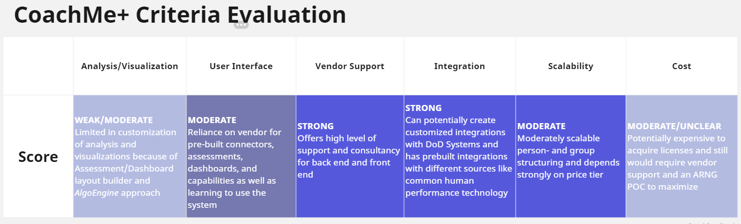

## Primary Recommendation: Power BI + Microsoft Enterprise

Microsoft Azure is a cloud provider dominating the current global cloud market alongside Google Cloud Platform and Amazon Web Services. After Q1 2023, AWS had 32% of the market share followed by Azure’s 23% and GCP’s 10%.[3] Each cloud provider offers various products and services for customers including storage, data warehouses, data lakes, and analytics and business intelligence (ABI) platforms. Out of these three different cloud providers, Azure stands out as the best provider to use for the ARNG’s H2F ecosystem because of its extensive product portfolio, ability to easily integrate with the existing Microsoft products already used by H2F stakeholders, and the existing Microsoft expertise within the DoD.[4] By using Azure products to host and create this backend and front end of the H2F ecosystem, the ABI platform used would be Azure’s Power BI. The following evaluation of Power BI’s capabilities and cost is based on the licensing of Power BI Pro/Premium Per User plus one Power BI Premium capacity.

Data Confidentiality, Integrity, and Privacy

The ARNG currently licenses Power BI from Microsoft’s cloud provider called *Azure Government*. Microsoft’s cloud provider for commercial usage is just called *Azure* and the distinction between the two is important to understand. Azure Government’s cloud is physically separated from Azure’s commercial one and is meant to be used by the DoD, federal/state/local government, and intelligence communities. Azure Government offers the same products offered by commercial Azure such as Power BI, data warehouse products, and data infrastructure, but this ecosystem was specifically made to meet compliance and security requirements so that U.S. government organizations could handle classified data.[5] Azure Government and all the products it offers, including Power BI, are FedRAMP authorized and have IL2, IL4, and IL5 authorizations. Azure Government can also meet compliance requirements such as the Defense Federal Acquisition Regulation Supplement and National Defense Authorization Act Section 889 and Section 1634.[6]

Data security is achieved through specific measures in a multi-layered approach to building the SMS. First, Azure Government has security assurance processes to create isolated services. This allows for storage and networking isolation with data encryption and compute isolation. Finally, user access controls with authentication and identity separation are implemented.[7]

Azure government developed *Azure Government Secret* and *Azure Government Top Secret* which is meant for U.S. agencies handling highly classified data. Azure Government Secret acquired Provisional Authorization (PA) at Department of Defense Impact Level 6 (IL6) and Intelligence Community Directive (ICD) 503 with facilities at ICD 705.[8] The data currently identified to be held within the H2F SMS does not surpass IL4 and IL5, but if the ARNG is interested in inputting data from higher ILs in the future, it could be done using one of Azure’s cloud solutions. But, by handling IL6 data in Azure, the functionality of the SMS decreases because many Azure services offered commercially can no longer be used for the SMS such as stream analytics, most Azure AI services, and Dynamic 365 services. Even when handling IL4 and IL5 data with Azure Government, a few Azure services cannot be used.[9]

Analysis & Visualization

Power BI allows users to interact with and connect different data sources to create reports. H2F leaders will be able to shape the combined data by renaming columns, removing rows, changing headers, etc. Microsoft Report Builder, a free desktop tool, can then be used to create paginated reports which can be published in a workspace.

Excel is a widely used tool and Power BI easily integrates with this fellow Microsoft product by offering capabilities like “Analyze with Excel”. This allows data from Power BI’s dashboard to be visualized as tables and charts on Excel and vice versa. Away from Excel, Power BI offers hundreds of data visuals and models.[10] For example, it provides clustering techniques, decomposition trees, key influencers visuals, and its own out-of-the-box support for users interested in using basic and advanced chart types. The basic chart types included are combination charts, tree maps, bubble charts and scatter diagrams. The advanced chart types include donut, gauge, and small multiple/trellis charts. Other chart types (ex. stacked area charts, chord diagram, Gantt chart, radar chart, stream graph) are not offered out of the box but can be imported for free from Microsoft’s AppSource, an online marketplace to browse and deploy additional services. Power BI also offers “quick create” which can analyze a table and automatically recommend different visualizations and layouts. For analysis, DAX (Data Analysis Expressions) is the native programming language used for Power BI and its statistical functions library provides functions for mean, median, min, max, mode, standard deviation, confidence interval, t-test, and chi-square. While users analyze the data within Power BI, administrators can analyze user activity on the platform with Power BI’s pre-made dashboard. User activity can provide H2F senior leaders valuable insight on the benefits and impact of deploying Power BI.[11] One unique aspect to note is Power BI’s usage of natural language– the ability of a computer program to understand the human language. Users can create their own dashboards away from enterprise dashboards and ask for queries in natural language. In addition, Power BI’s “Smart Narratives” provides quick highlights and summaries of displayed data in natural language.[12]

User interface

Power BI can be used to create multiple user interfaces for the different H2F stakeholder groups. But Power BI Desktop can only be downloaded on Windows systems.[13] Power BI cannot be used to build on MacOS devices, but dashboards can still be viewed. Depending on how many H2F personnel are currently using a Mac, this could potentially be a major drawback. Despite the limitations of Power BI desktop, Power BI has a native app for iOS and Android smartphones/tablets.[14] For H2F Soldiers, access to their user interface via a phone app allows them to easily input and view their own data on the go. The mobile app also allows offline interaction with dashboards and reports users accessed previously in a “view only” mode.[15] Soldiers can also view a consolidated page for resources related to the five H2F domains in order to learn and improve their health. This consolidated resource page can be created by Microsoft Power Pages and accessed by Soldiers through a link or tab embedded into their user interface. All H2F stakeholders can take advantage of Power BI’s ability to foster real time collaboration and socialization in the app or web. Discussion threads, comments, and Microsoft Teams chats can be made under reports and visuals.[16]

Managing different user interfaces requires strong access controls and security measures. Users can share, embed, and publish visualizations while maintaining full functionality and security of the visualization by setting access permissions (view or edit) and sensitivity labels.[17] Users can also assign row and object level security permissions to content, but this requires the technical ability to use DAX. Object level security is not provided within Power BI and requires external tools like Tabular Editor.[18]

Vendor Support

When compared to CoachMe+ and Smartabase, using Power BI comes with significantly less vendor support in building the back end of the Azure repository and deploying Power BI. To use Power BI, the H2F team needs to have the appropriate amount of internal personnel (IPs) and technical expertise to carry out the different steps of the data cycle. These steps include data integration, data management, data virtualization, data analytics, and data governance. For this, IPs need to be familiar with both DAX and the M language and they need to be familiar with Microsoft's catalog of products and tools.[19] To build the H2F repository, IPs will need to understand the function and implementation of Microsoft tools for every step. For example, after building data pipelines, data scientists can use Azure Machine Learning Studio for preprocessing and data preparation. Certain capabilities within Power BI, like sensitivity labels, are not available out-of-the-box and require additional tools like Azure Information Protection Premium.[20] After the repository is built and rolled out, IPs are needed for the long term to troubleshoot, maintain, and update the repository. At the basic level, Azure provides a free support plan that includes self-help online resources, documentation, and training videos for IPs. Because of how widely used Azure products are, there is an extensive number of resources and documentation to help guide IPs through the steps of the data cycle but depending on their experience and skill, the amount of material may be overwhelming.[21] The basic support plan does not include consulting services, API support, architecture support, or direct technical support. For IPs to access these additional services, H2F admins can choose one of three paid support plans to purchase.[22] The quality of Azure’s support services has received mixed reviews online, so the experience is dependent on the Azure representatives assigned to work with H2F IPs.

Although there is no extensive support, H2F will have increased flexibility and limited vendor dependency. H2F admins will not be dependent on the vendor’s time schedule and pre-built capabilities when making dashboards, interfaces, and customizations. With experienced IPs and Power BI, the back end and front end of the H2F repository can be completely built and managed internally.

Integration

Although integration with data sources will not be set up by the vendor, it is important to understand Power BI’s integration capabilities. Power BI supports connectivity to:

* Sources: Google Analytics, Adobe Marketo, Salesforce, and Microsoft Dynamics 365
* Data virtualization: AtScale cubes, Denodo, Data Virtuality LDW and Dremio
* Cloud data lakes: AWS S3, GCP Storage, Azure Data Lake, etc.
* NoSQL data sources

Power BI also has OLAP connectivity and connectivity to other A&BI platforms. Data in MicroStrategy can be reused to create Power Bi visualizations and reports and vice versa, data in Power BI can be reused by a platform like Tableau to create reports. The data is not copied into the connected third-party platform. Power BI can also integrate with external scripts of code in R and Python.[23] A unique feature of Power BI is its ability to consume streaming data through live connections to data sources like social media, service usage metrics, or other time-sensitive data collectors. Streaming dataflows allow users to create visualizations and reports based on real time streaming data. When integration is set up with all data sources, Power BI does not have the ability to trigger an automatic data refresh based on changes to data in the original data source. But automatic refreshes of datasets can be put on a set schedule using Power BI REST APIs.[24]

Scalability  
 Each Power BI Premium capacity has defined its total storage capacity, RAM, CPUs per minute, and number of Direct Queries per second but autoscaling of the compute can be enabled. Autoscaling allows Azure services to scale up during workload peaks and scale down during load drops. Additional Power BI Premium capacities need to be purchased if additional compute and storage is needed.[25]

Cost

The Department of Defense and the Army National Guard already have licenses for Azure products and many states are currently working to provide all Soldiers and staff with Power BI premium licenses. Power BI takes advantage of this existing resource, but IPs and expertise needs to be available internally or recruited to build the Azure repository and deploy Power BI. The purchase of support plans that offer IPs additional services will be an additional cost per month, starting from $29 and going up to $1000.[26]

Table 3. Microsoft Suite Criteria Evaluation

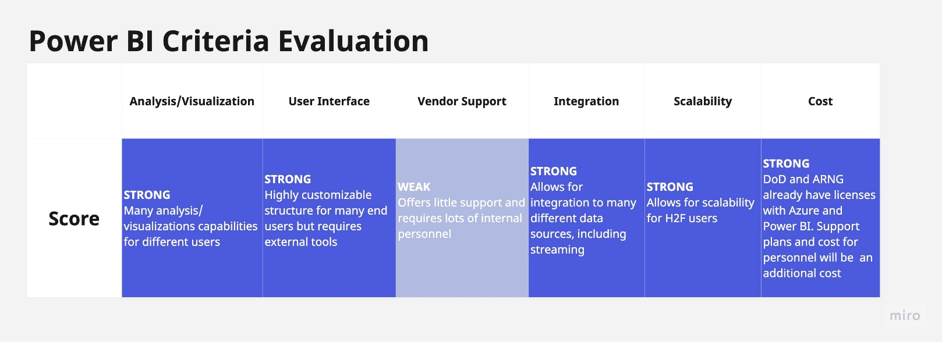

Figure 2. ARNG H2F Data Architecture with the Microsoft Suite

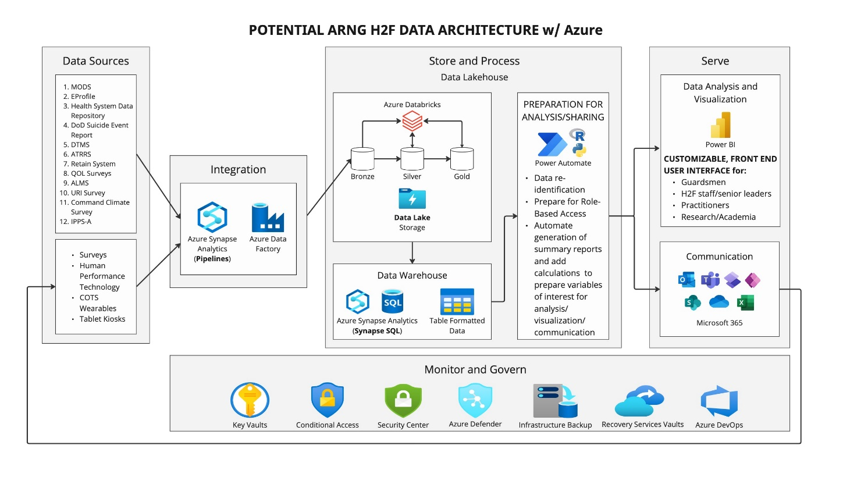

The above image shows the H2F’s SMS data architecture using the Azure enterprise. After purchasing the necessary licenses and personnel, IPs will start building the H2F repository by finalizing the data sources and fulfilling all data security regulations such as FedRAMP and IL levels. After the data sources are finalized, personnel can start to build data pipelines to integrate with the different data sources and transport that data into the SMS. Building data pipelines includes ETL (extract, transform, load) processes and setting up APIs. IPs can perform ETL processes by using Power Query to connect to data sources, transform data using arithmetic and logical functions, and load data into Azure’s data warehouse and data lake. Advanced transformations could be done using DAX, R, or Python programming languages.[27] Once these pipelines are built, the data is prepared for the final step of serving the end user in an analytics or data visualization platform.

# Chapter 4. Discussion

As the ARNG H2F moves forward with creating a long-term SMS, our team’s research highlights additional key points to note about our platform recommendation and implementation.

Using Power BI as the A&BI platform on an Azure back end allows for an interchangeable front end. For the back end, Smartabase and CoachMe+ have their own data warehouses that the ARNG can use but both these platforms can also be supported on data warehouses from Azure, AWS, or GCP. Using the data warehouse from Smartabase and CoachMe+ is the most common approach customers take but this means that if a new A&BI platform becomes available in the future and the ARNG H2F system wants to discontinue a license with Smartabase or CoachMe+, they lose the data warehouse where all the data from the different sources is stored after integration. The data warehouse would need to be rebuilt and integrations built by the original vendors would need to be re-done by the new vendor or internal DoD personnel. This would mean that the back end of the SMS could need to completely be rebuilt. To create the back-end data architecture in a way that is not contingent on a particular platform, the DoD can use a product like the Azure data lake house which will ensure ownership and security of the data. With a locked in Azure back end, Power BI or any analytics platform can easily be switched out for a new A&BI platform that can be supported by a modern data warehouse and infrastructure.

By speaking with different POCs, our team found that decentralized data is an issue many individuals and groups within the DoD are facing, and many have tried to create central repositories for different purposes. The ARNG H2F SMS is not an isolated effort. An article published on the U.S. Army website by Ellen Summey explains the creation of a central repository called Army Leader Dashboard, now known as Army Vantage. The article quotes Lt. Col. Rob Wolfe who says, “‘There are a lot of systems that allow you to look at people, to look at equipment, to look at training, but there are not any systems that allow you to look across all those areas and see how resourcing decisions in training affect people, or vice versa. We're really trying to give leaders a tool to make strategic resource decisions and understand the impacts across the Army’”.[28] The Program Executive Office for Enterprise Information Systems successfully built and rolled out Army Vantage and faced the obstacles that come with implementation– the ARNG H2F can expect to face similar obstacles. Another central repository currently being developed is the Army Information Training System (ATIS). ATIS hopes to achieve and maintain readiness by centralizing Soldier training data and information along with Soldier education resources.[29] These three systems address the same problem but with different purposes and the ARNG H2F can reach out to internal contacts at Army Vantage and ATIS for the sharing of ideas and solutions. By far, the most relevant development effort to the ARNG H2F SMS is the Army Active Duty H2F SMS. Active Duty is currently designing their own H2F data architecture and like the approach used in this report, they are identifying the best back end and front-end software to use based on different criteria. Smartabase and CoachMe+ are two platforms being considered by Active Duty. Although ARNG and Active Duty acquire funding and licensing separately, collaboration between both branches could expedite implementation while potentially cutting costs if resources and steps were shared. This would prevent both parties from re-inventing the wheel. Active Duty is currently ahead of ARNG in the development of an H2F SMS, but the findings Active Duty has made so far are directly applicable to ARNG.

Before the H2F SMS is rolled out to units, Soldiers, and senior leaders within the ARNG, sufficient education and clear expectations on the capabilities of this resource need to be set in place. H2F stakeholders need to understand how to use the SMS, what it can do, and why it is important before they are given access to it. The success and ROI of the SMS depends on its usage and a lack of understanding and education can put development efforts to waste. Mandatory training sessions and “instruction manuals” for the different SMS users can be created by the ARNG and the A&BI platform vendor and DoD internal development/technical team can help inform the information given out.

# Chapter 5. Conclusion and Future Directions

Through our research, we explored different platforms that could help the ARNG centralize its central repository for metrics, data collection, and resources related to H2F. Our deliverable demonstrates that several platforms can feasibly support the ARNG in its efforts to centralize metrics from the state to the national level. Each of these platforms has advantages that will help the ARNG measure the success of the H2F system. Our two short-term recommendations are based on our research, including interviews with ARNG members at both the state and national level and help improve how metrics can be measured nationally and expand access to resources relating to the H2F system. While our research has led to a deliverable offering constructive recommendations on how the ARNG can centralize its data repository, it would be advantageous to continue researching this topic.

**Works Cited**

Antelmi, Joe, and Doreen Galli. “In-Depth Assessment of Microsoft Power BI.” Gartner. December 21, 2018.

“Army Training Information System.” PEO EIS.

<https://www.eis.army.mil/programs/atis>.

“AWS vs Azure vs Google Cloud - Detailed Cloud Comparison.” 2019. Intellipaat Blog. June 25, 2019.

<https://intellipaat.com/blog/aws-vs-azure-vs-google-cloud/?US>.

“Azure and Other Microsoft Cloud Services Compliance Scope - Azure Government.” Learn.microsoft.com. July 28, 2023. <https://learn.microsoft.com/en-us/azure/azure-government/compliance/azure-services-in-fedramp-auditscope#azure-government-services-by-audit-scope>.

“Azure Government Compliance - Azure Government.” Learn.microsoft.com.

<https://learn.microsoft.com/en-us/azure/azure-government/documentation-government-plan-compliance>.

“Azure Government for National Security | Microsoft Azure.” n.d. Azure.microsoft.com.

<https://azure.microsoft.com/en-us/explore/global-infrastructure/government/national-security/>.

“Azure Guidance for Secure Isolation - Azure Government.” Learn.microsoft.com.

<https://learn.microsoft.com/en-us/azure/azure-government/azure-secure-isolation-guidance>.

“Azure Support Plans Comparison | Microsoft Azure.” n.d. Azure.microsoft.com.

<https://azure.microsoft.com/en-us/support/plans>.

Bartwal, Anupam. "GCP Vs AWS Vs Azure Comparison Overview." K21 Academy. June 23, 2023.

<https://k21academy.com/amazon-web-services/aws-solutions-architect/aws-vs-azure-vsgcp/#:~:text=AWS%27s%20largest%20instance%2C%20with%203.84,the%20lead%20in%20our%20comparison>.

Grinston, Sgt. Michael A, Gen. James C McConville, and Ryan D McCarthy. The US Army Holistic Health and Fitness Operating Concept, October 1, 2020.

<https://www.army.mil/e2/downloads/rv7/acft/h2f_operating_concept.pdf>.

LaMear, Rob. n.d. “Azure Government Cloud vs Commercial.” US Cloud.

<https://www.uscloud.com/azure-government-cloud-vs-commercial/>.

O'Callaghan, Georgia. “Solution Comparison for SaaS Analytics and Business Intelligence Platforms.” Gartner, July 25, 2022. ‌

Richter, Felix. 2023. “Infographic: Amazon Dominates Public Cloud Market.” Statista Infographics. Statista. April 28, 2023.

<https://www.statista.com/chart/18819/worldwide-market-share-of-leading-cloud-infrastructure-service-providers/>.

Summey, Ellen. “Army Leader Dashboard, Creating Insight-Driven Decisions.” US Army. August 4, 2023. <https://www.army.mil/article/224036/army_leader_dashboard_creating_insight_driven_decisions.‌>

Technologies, Mindmajix. 2021. “Looker vs. Power BI: A Data Visualization Tool Comparison.” Mindmajix. April 22, 2021. <https://mindmajix.com/looker-vs-power-bi>.

The National Guard - Official Website of the National Guard, n.d.

<https://www.nationalguard.mil/>.

1. Sgt. Michael A Grinston, Gen. James C McConville, and Ryan D McCarthy, The US Army Holistic Health and Fitness Operating Concept, October 1, 2020, https://www.army.mil/e2/downloads/rv7/acft/h2f_operating_concept.pdf.
2. Renee Garett et al., “A Literature Review: Website Design and User Engagement,” Online journal of communication and media technologies, July 2016, https://www.ncbi.nlm.nih.gov/pmc/articles/PMC4974011/.
3. Felix Richter, “Infographic: Amazon Dominates Public Cloud Market,” Statista Infographics, Statista, April 28, 2023. <https://www.statista.com/chart/18819/worldwide-market-share-of-leading-cloud-infrastructure-service-providers/>.
4. Anupam Bartwal, "GCP Vs AWS Vs Azure Comparison Overview,” K21 Academy, June 23, 2023. <https://k21academy.com/amazon-web-services/aws-solutions-architect/aws-vs-azure-vs-gcp/#:~:text=AWS%27s%20largest%20instance%2C%20with%203.84,the%20lead%20in%20our%20comparison>.
5. Rob LaMear, “Azure Government Cloud vs Commercial,” US Cloud. <https://www.uscloud.com/azure-government-cloud-vs-commercial/>.
6. “Azure Government Compliance - Azure Government,” Learn.microsoft.com. <https://learn.microsoft.com/en-us/azure/azure-government/documentation-government-plan-compliance>.
7. “Azure Guidance for Secure Isolation - Azure Government,” Learn.microsoft.com. <https://learn.microsoft.com/en-us/azure/azure-government/azure-secure-isolation-guidance>.
8. “Azure Government for National Security | Microsoft Azure,” Azure.microsoft.com. <https://azure.microsoft.com/en-us/explore/global-infrastructure/government/national-security/>.
9. “Azure and Other Microsoft Cloud Services Compliance Scope - Azure Government,” Learn.microsoft.com, July 28, 2023. <https://learn.microsoft.com/en-us/azure/azure-government/compliance/azure-services-in-fedramp-auditscope#azure-government-services-by-audit-scope>.
10. Mindmajix Technologies, “Looker vs. Power BI: A Data Visualization Tool Comparison,” Mindmajix, April 22, 2021. https://mindmajix.com/looker-vs-power-bi.
11. Georgia O'Callaghan, “Solution Comparison for SaaS Analytics and Business Intelligence Platforms,” Gartner, July 25, 2022.
12. Georgia O'Callaghan, “Solution Comparison for SaaS Analytics and Business Intelligence Platforms,” Gartner, July 25, 2022.
13. Mindmajix Technologies, “Looker vs. Power BI: A Data Visualization Tool Comparison,” Mindmajix, April 22, 2021. <https://mindmajix.com/looker-vs-power-bi>.
14. Georgia O'Callaghan, “Solution Comparison for SaaS Analytics and Business Intelligence Platforms,” Gartner, July 25, 2022.
15. Georgia O'Callaghan, “Solution Comparison for SaaS Analytics and Business Intelligence Platforms,” Gartner, July 25, 2022.
16. Joe Antelmi and Doreen Galli, “In-Depth Assessment of Microsoft Power BI,” Gartner, December 21, 2018.
17. Joe Antelmi and Doreen Galli, “In-Depth Assessment of Microsoft Power BI,” Gartner, December 21, 2018.
18. Joe Antelmi and Doreen Galli, “In-Depth Assessment of Microsoft Power BI,” Gartner, December 21, 2018.
19. Joe Antelmi and Doreen Galli, “In-Depth Assessment of Microsoft Power BI,” Gartner, December 21, 2018.
20. Georgia O'Callaghan, “Solution Comparison for SaaS Analytics and Business Intelligence Platforms,” Gartner, July 25, 2022.
21. “AWS vs Azure vs Google Cloud - Detailed Cloud Comparison,” Intellipaat Blog, June 25, 2019. <https://intellipaat.com/blog/aws-vs-azure-vs-google-cloud/?US>.
22. “Azure Support Plans Comparison | Microsoft Azure,” Azure.microsoft.com. <https://azure.microsoft.com/en-us/support/plans>.
23. Joe Antelmi and Doreen Galli, “In-Depth Assessment of Microsoft Power BI,” Gartner, December 21, 2018.
24. Georgia O'Callaghan, “Solution Comparison for SaaS Analytics and Business Intelligence Platforms,” Gartner, July 25, 2022.
25. Georgia O'Callaghan, “Solution Comparison for SaaS Analytics and Business Intelligence Platforms,” Gartner, July 25, 2022.
26. “Azure Support Plans Comparison | Microsoft Azure,” Azure.microsoft.com. <https://azure.microsoft.com/en-us/support/plans>.
27. Georgia O'Callaghan, “Solution Comparison for SaaS Analytics and Business Intelligence Platforms,” Gartner, July 25, 2022.
28. Ellen Summey, “Army Leader Dashboard, Creating Insight-Driven Decisions,” US Army, August 4, 2023. https://www.army.mil/article/224036/army_leader_dashboard_creating_insight_driven_decisions.
29. “Army Training Information System,” PEO EIS. https://www.eis.army.mil/programs/atis.